INTRODUCTION TO SQL

Pronounced as SEQUEL: Structured English QUERY Language

- Pure non-procedural query language

- Designed and developed by IBM, Implemented by Oracle

- 1978 System/R IBM- 1st Relational DBMS

- 1979 Oracle and Ingres

- 1982 SQL/DS and DB2 IBM

- Accepted by both ANSI + ISO as Standard Query Language for any RDBMS

- SQL86 (SQL1) : first by ANSI and ratified by ISO (SQL-87), minor revision on 89 (SQL-89)

- SQL92 (SQL2) : major revision

- SQL99 (SQL3) : add recursive query, trigger, some OO features, and non-scholar type

- SQL2003 : XML, Window functions, and sequences (Not free)

- Supports all the three sublanguages of DBMS: DDL, DML, DCL

- Supports Aggregate functions, String Manipulation functions, Set theory operations, Date Manipulation functions, rich set of operators ( IN, BETWEEN, LIKE, IS NULL,

EXISTS)

- Supports REPORT writing features and Forms for designing GUI based applications

DATA DEFINITION, CONSTRAINTS, AND SCHEMA CHANGES

Used to CREATE, ALTER, and DROP the descriptions of the database tables (relations)

Data Definition in SQL

CREATE, ALTER and DROP

table…………………………………….……relation

row……………………………………..…….tuple

column………………………………….……attribute

DATA TYPES

- Numeric: NUMBER, NUMBER(s,p), INTEGER, INT, FLOAT, DECIMAL

- Character: CHAR(n), VARCHAR(n), VARCHAR(n), CHAR VARYING(n)

- Bit String: BLOB, CLOB

- Boolean: true, false, and null

- Date and Time: DATE (YYYY-MM-DD) TIME( HH:MM:SS)

- Timestamp: DATE + TIME

- USER Defined types

CREATE SCHEMA

Specifies a new database schema by giving it a name

Ex: CREATE SCHEMA COMPANY AUTHORIZATION Jsmith;

CREATE TABLE

- Specifies a new base relation by giving it a name, and specifying each of its attributes and their data types

Syntax of CREATE Command:

CREATE TABLE <table name> ( <Attribute A1> <Data Type D1> [< Constarints>], <Attribute A2> <Data Type D2> [< Constarints>],

…….

<Attribute An> <Data Type Dn> [< Constarints>],

[<integrity-constraint1>, <integrity-constraint k> ] );

  - A constraint NOT NULL may be specified on an attribute A constraint NOT NULL may be specified on an attribute Ex: CREATE TABLE DEPARTMENT (

DNAME VARCHAR(10) NOT NULL,

DNUMBER INTEGER NOT NULL,

MGRSSN CHAR(9), MGRSTARTDATE CHAR(9) );

- Specifying the unique, primary key attributes, secondary keys, and referential integrity constraints (foreign keys).

Ex: CREATE TABLE DEPT ( DNAME VARCHAR(10) NOT NULL,

DNUMBER INTEGER NOT NULL, MGRSSN CHAR(9), MGRSTARTDATE CHAR(9),

PRIMARY KEY (DNUMBER), UNIQUE (DNAME),

FOREIGN KEY (MGRSSN) REFERENCES EMP(SSN));

- We can specify RESTRICT, CASCADE, SET NULL or SET DEFAULT on referential integrity constraints (foreign keys)

Ex: CREATE TABLE DEPT ( DNAME VARCHAR(10) NOT NULL,
DNUMBER INTEGER NOT NULL,

MGRSSN CHAR(9), MGRSTARTDATE CHAR(9),

PRIMARY KEY (DNUMBER), UNIQUE (DNAME),
FOREIGN KEY (MGRSSN) REFERENCES EMP

ON DELETE SET DEFAULT ON UPDATE CASCADE);

DROP TABLE

- Used to remove a relation (base table) and its definition.

- The relation can no longer be used in queries, updates, or any other commands since its description no longer exists

Example: DROP TABLE DEPENDENT;

ALTER TABLE:

- Used to add an attribute to/from one of the base relations drop constraint -- The new attribute will have NULLs in all the tuples of the relation right after the command is executed; hence, the NOT NULL constraint is not allowed for such an attribute.

Example: ALTER TABLE EMPLOYEE ADD JOB VARCHAR (12);

- The database users must still enter a value for the new attribute JOB for each EMPLOYEE tuple. This can be done using the UPDATE command.

DROP A COLUMN (AN ATTRIBUTE)

- ALTER TABLE COMPANY.EMPLOYEE DROP ADDRESS CASCADE; All constraints and views that reference the column are dropped automatically, along with the column. ALTER TABLE COMPANY.EMPLOYEE DROP ADDRESS RESTRICT; Successful if no views or constraints reference the column. ALTER TABLE COMPANY.DEPARTMENT ALTER MGRSSN DROP DEFAULT;

- ALTER TABLE COMPANY.DEPARTMENT ALTER MGRSSN SET DEFAULT

“333445555”;

BASIC QUERIES IN SQL

- SQL has one basic statement for retrieving information from a database; the SLELECT statement

- This is not the same as the SELECT operation of the relational algebra

- Important distinction between SQL and the formal relational model;

- SQL allows a table (relation) to have two or more tuples that are identical in all their attribute values

- Hence, an SQL relation (table) is a multi-set (sometimes called a bag) of tuples; it is not a set of tuples

- SQL relations can be constrained to be sets by using the CREATE UNIQUE INDEX command, or by using the DISTINCT option

- Basic form of the SQL SELECT statement is called a mapping of a SELECT-FROM-WHERE block

SELECT <attribute list> FROM <table list> WHERE <condition>

- <attribute list> is a list of attribute names whose values are to be retrieved by the query

- <table list > is a list of the relation names required to process the query

- <condition> is a conditional (Boolean) expression that identifies the tuples to be retrieved by the query

SIMPLE SQL QUERIES

Basic SQL queries correspond to using the following operations of the relational algebra:

SELECT

PROJECT

JOIN

All subsequent examples uses COMPANY database as shown below:

Example of a simple query on one relation

Query 0: Retrieve the birth date and address of the employee whose name is ‘John B.

Smith’.

Q0: SELECT BDATE, ADDRESS FROM EMPLOYEE

WHERE FNAME=‘John’ AND MINIT=‘B’ AND LNAME=‘Smith’

Similar to a SELECT-PROJECT pair of relational algebra operations: The SELECT-clause specifies the projection attributes and the WHERE-clause specifies the selection condition However, the result of the query may contain duplicate tuples

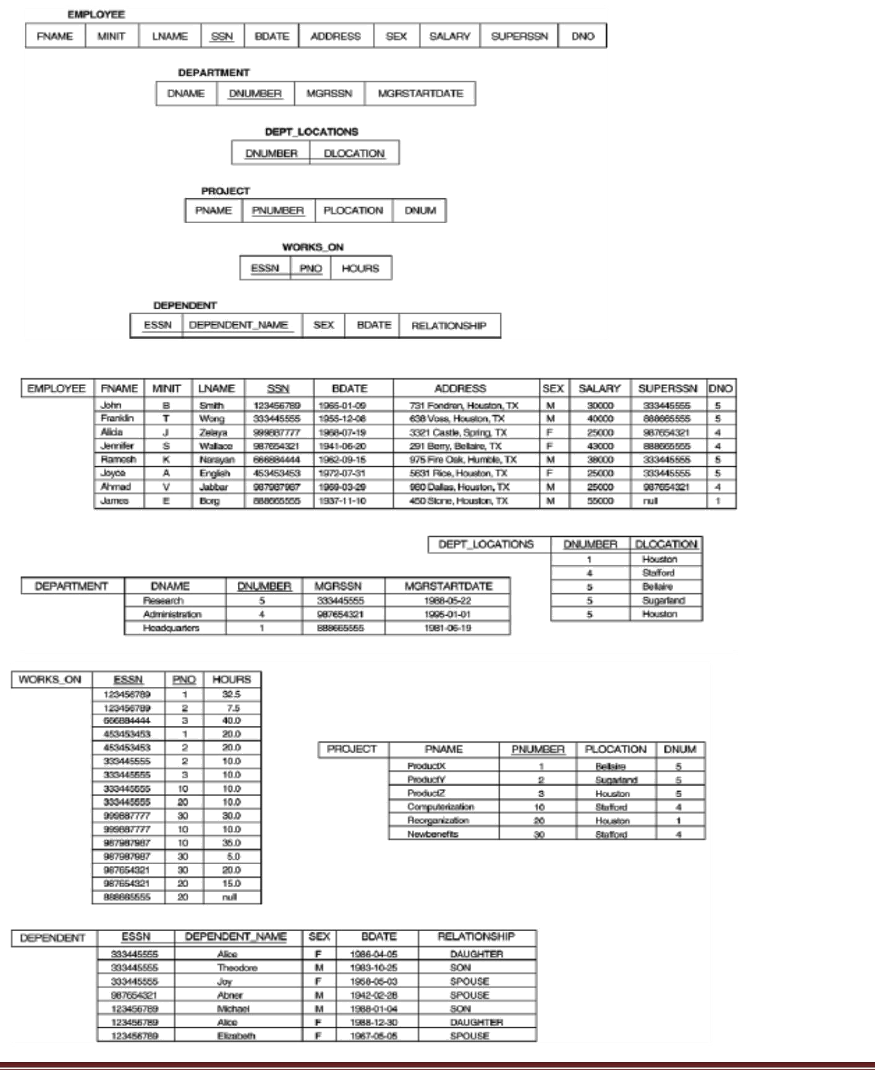

Example of a simple query on two relations

Query 1: Retrieve the name and address of all employees who work for the ‘Research’

department.

Q1: SELECT FNAME, LNAME, ADDRESS FROM EMPLOYEE, DEPARTMENT WHERE DNAME=‘Research’ AND DNUMBER=DNO

Similar to a SELECT-PROJECT-JOIN sequence of relational algebra operations (DNAME=‘Research’) is a selection condition (corresponds to a SELECT operation in relational algebra) (DNUMBER=DNO) is a join condition (corresponds to a JOIN operation in relational algebra)

Example of a simple query on three relations

Query 2: For every project located in ‘Stafford’, list the project number, the controlling department number, and the department manager’s last name, address, and birth date.

Q2: SELECT PNUMBER, DNUM, LNAME, BDATE, ADDRESS FROM PROJECT, DEPARTMENT, EMPLOYEE WHERE DNUM=DNUMBER AND MGRSSN=SSN AND PLOCATION=‘Stafford’

In Q2, there are two join conditions The join condition DNUM=DNUMBER relates a project to its controlling department The join condition MGRSSN=SSN relates the controlling department to the employee who manages that department

ALIASES, * AND DISTINCT, EMPTY WHERE-CLAUSE

- In SQL, we can use the same name for two (or more) attributes as long as the attributes are in different relations

- A query that refers to two or more attributes with the same name must qualify the attribute name with the relation name by prefixing the relation name to the attribute name Example: EMPLOYEE.LNAME, DEPARTMENT.DNAME

- Some queries need to refer to the same relation twice. In this case, aliases are given to the relation name

Example

Query 3: For each employee, retrieve the employee’s name, and the name of his or her

immediate supervisor.

Q3: SELECT E.FNAME, E.LNAME, S.FNAME, S.LNAME FROM EMPLOYEE E S WHERE E.SUPERSSN=S.SSN

In Q3, the alternate relation names E and S are called aliases or tuple variables for the EMPLOYEE relation We can think of E and S as two different copies of EMPLOYEE; E represents employees in role of supervisees and S represents employees in role of supervisors

Aliasing can also be used in any SQL query for convenience. Can also use the AS keyword to specify aliases

Q3: SELECT E.FNAME, E.LNAME, S.FNAME, S.LNAME FROM EMPLOYEE AS E, EMPLOYEE AS S WHERE E.SUPERSSN=S.SSN

UNSPECIFIED WHERE-clause

A missing WHERE-clause indicates no condition; hence, all tuples of the relations in the FROM-clause are selected. This is equivalent to the condition WHERE TRUE Example:

Query 4: Retrieve the SSN values for all employees.

Q4: SELECT SSN FROM EMPLOYEE

If more than one relation is specified in the FROM-clause and there is no join condition, then the

CARTESIAN PRODUCT of tuples is selected

Example:

Q5: SELECT SSN, DNAME FROM EMPLOYEE, DEPARTMENT

Note: It is extremely important not to overlook specifying any selection and join conditions in the WHERE-clause; otherwise, incorrect and very large relations may result

USE OF *

To retrieve all the attribute values of the selected tuples, a * is used, which stands for all the

attributes

Examples:

Retrieve all the attribute values of EMPLOYEES who work in department 5.

Q1a: SELECT * FROM EMPLOYEE WHERE DNO=5

Retrieve all the attributes of an employee and attributes of DEPARTMENT he works in for every employee of ‘Research’ department.

Q1b: SELECT * FROM EMPLOYEE, DEPARTMENT WHERE DNAME=‘Research’ AND DNO=DNUMBER

USE OF DISTINCT

SQL does not treat a relation as a set; duplicate tuples can appear. To eliminate duplicate tuples in a query result, the keyword DISTINCT is used

Example: the result of Q1c may have duplicate SALARY values whereas Q1d does not have any duplicate values

Q1c: SELECT SALARY FROM EMPLOYEE Q1d: SELECT DISTINCT SALARY FROM EMPLOYEE

SET OPERATIONS

SQL has directly incorporated some set operations such as union operation (UNION), set difference (MINUS) and intersection (INTERSECT) operations. The resulting relations of these set operations are sets of tuples; duplicate tuples are eliminated from the result. The set operations apply only to union compatible relations; the two relations must have the same attributes and the attributes must appear in the same order

Query 5: Make a list of all project numbers for projects that involve an employee whose last name is ‘Smith’ as a worker or as a manager of the department that controls the project.

Q5: (SELECT PNAME FROM PROJECT, DEPARTMENT, EMPLOYEE WHERE DNUM=DNUMBER AND MGRSSN=SSN AND LNAME=‘Smith’)

UNION

(SELECT PNAME FROM PROJECT, WORKS_ON, EMPLOYEE WHERE PNUMBER=PNO AND ESSN=SSN AND NAME=‘Smith’)

NESTING OF QUERIES

A complete SELECT query, called a nested query, can be specified within the WHERE-clause of another query, called the outer query. Many of the previous queries can be specified in an alternative form using nesting

Query 6: Retrieve the name and address of all employees who work for the ‘Research’ department.

Q6: SELECT FNAME, LNAME, ADDRESS FROM EMPLOYEE WHERE DNO IN (SELECT DNUMBER FROM DEPARTMENT WHERE DNAME=‘Research’ )

Note: The nested query selects the number of the ‘Research’ department. The outer query selects an EMPLOYEE tuple if its DNO value is in the result of either nested query. The comparison operator IN compares a value v with a set (or multi-set) of values V, and evaluates to TRUE if v is one of the elements in V

In general, we can have several levels of nested queries. A reference to an unqualified attribute refers to the relation declared in the innermost nested query. In this example, the nested query is not correlated with the outer query

CORRELATED NESTED QUERIES

If a condition in the WHERE-clause of a nested query references an attribute of a relation declared in the outer query, the two queries are said to be correlated. The result of a correlated nested query is different for each tuple (or combination of tuples) of the relation(s) the outer query

Query 7: Retrieve the name of each employee who has a dependent with the same first name as the employee.

Q7: SELECT E.FNAME, E.LNAME FROM EMPLOYEE AS E WHERE E.SSN IN (SELECT ESSN FROM DEPENDENT WHERE ESSN=E.SSN AND E.FNAME=DEPENDENT_NAME)

In Q7, the nested query has a different result in the outer query. A query written with nested SELECT... FROM… WHERE... blocks and using the = or IN comparison operators can always be expressed as a single block query. For example, Q7 may be written as in Q7a

Q7a: SELECT E.FNAME, E.LNAME FROM EMPLOYEE E, DEPENDENT D WHERE E.SSN=D.ESSN AND E.FNAME=D.DEPENDENT_NAME

THE EXISTS FUNCTION

EXISTS is used to check whether the result of a correlated nested query is empty (contains no tuples) or not. We can formulate Query 7 in an alternative form that uses EXIST.

Q7b: SELECT FNAME, LNAME FROM EMPLOYEE

WHERE EXISTS (SELECT * FROM DEPENDENT WHERE SSN=ESSN AND FNAME=DEPENDENT_NAME)

Query 8: Retrieve the names of employees who have no dependents.

Q8: SELECT FNAME, LNAME FROM EMPLOYEE

WHERE NOT EXISTS

(SELECT * FROM DEPENDENT WHERE SSN=ESSN)

Note: In Q8, the correlated nested query retrieves all DEPENDENT tuples related to an EMPLOYEE tuple. If none exist, the EMPLOYEE tuple is selected

EXPLICIT SETS

It is also possible to use an explicit (enumerated) set of values in the WHERE-clause rather than a nested query

Query 9: Retrieve the social security numbers of all employees who work on project number 1, 2, or 3.

Q9: SELECT DISTINCT ESSN FROM WORKS_ON WHERE PNO IN (1, 2, 3)

NULLS IN SQL QUERIES

SQL allows queries that check if a value is NULL (missing or undefined or not applicable). SQL uses IS or IS NOT to compare NULLs because it considers each NULL value distinct from other NULL values, so equality comparison is not appropriate.

Query 10: Retrieve the names of all employees who do not have supervisors.

Q10: SELECT FNAME, LNAME FROM EMPLOYEE

WHERE SUPERSSN IS NULL

Note: If a join condition is specified, tuples with NULL values for the join attributes are not included in the result

AGGREGATE FUNCTIONS

Include COUNT, SUM, MAX, MIN, and AVG

Query 11: Find the maximum salary, the minimum salary, and the average salary among all employees.

Q11: SELECT MAX (SALARY), MIN(SALARY), AVG(SALARY)

FROM EMPLOYEE

Note: Some SQL implementations may not allow more than one function in the SELECT-clause

Query 12: Find the maximum salary, the minimum salary, and the average salary among

employees who work for the ‘Research’ department.

Q12: SELECT MAX (SALARY), MIN(SALARY), AVG(SALARY) FROM

EMPLOYEE, DEPARTMENT WHERE DNO=DNUMBER AND DNAME=‘Research’

Queries 13 and 14: Retrieve the total number of employees in the company (Q13), and the number of employees in the ‘Research’ department (Q14).

Q13: SELECT COUNT (*) FROM EMPLOYEE

Q14: SELECT COUNT (*) FROM EMPLOYEE, DEPARTMENT

WHERE DNO=DNUMBER AND DNAME=‘Research’

GROUPING

- In many cases, we want to apply the aggregate functions to subgroups of tuples in a relation

- Each subgroup of tuples consists of the set of tuples that have the same value for the grouping attribute(s)

- The function is applied to each subgroup independently

- SQL has a GROUP BY-clause for specifying the grouping attributes, which must also appear in the SELECT-clause

Query 15: For each department, retrieve the department number, the number of

employees in the department, and their average salary.

Q15: SELECT DNO, COUNT (*), AVG (SALARY)

FROM EMPLOYEE GROUP BY DNO

- In Q15, the EMPLOYEE tuples are divided into groups. Each group having the same value for the grouping attribute DNO

- The COUNT and AVG functions are applied to each such group of tuples separately

- The SELECT-clause includes only the grouping attribute and the functions to be applied on each group of tuples

- A join condition can be used in conjunction with grouping

Query 16: For each project, retrieve the project number, project name, and the number of

employees who work on that project.

Q16: SELECT PNUMBER, PNAME, COUNT (*)

FROM PROJECT, WORKS_ON

WHERE PNUMBER=PNO

GROUP BY PNUMBER, PNAME

THE HAVING-CLAUSE

Sometimes we want to retrieve the values of these functions for only those groups that satisfy certain conditions. The HAVING-clause is used for specifying a selection condition on groups (rather than on individual tuples)

Query 17: For each project on which more than two employees work, retrieve the project number, project name, and the number of employees who work on that project.

Q17: SELECT PNUMBER, PNAME, COUNT (*) FROM PROJECT, WORKS_ON WHERE PNUMBER=PNO GROUP BY PNUMBER, PNAME

HAVING COUNT (*) > 2

SUBSTRING COMPARISON

The LIKE comparison operator is used to compare partial strings. Two reserved characters are used: ‘%’ (or ‘*’ in some implementations) replaces an arbitrary number of characters, and ‘_’ replaces a single arbitrary character.

Query 18: Retrieve all employees whose address is in Houston, Texas. Here, the value of the

ADDRESS attribute must contain the substring ‘Houston,TX’ in it.

Q18: SELECT FNAME, LNAME

FROM EMPLOYEE WHERE ADDRESS LIKE ‘%Houston,TX%’

Query 19: Retrieve all employees who were born during the 1950s.

Here, ‘5’ must be the 8th character of the string (according to our format for date), so the BDATE value is ‘_______5_’, with each underscore as a place holder for a single arbitrary character.

Q19: SELECT FNAME, LNAME

FROM EMPLOYEE WHERE BDATE LIKE ‘_______5_’

Note: The LIKE operator allows us to get around the fact that each value is considered atomic and indivisible. Hence, in SQL, character string attribute values are not atomic

ARITHMETIC OPERATIONS

The standard arithmetic operators ‘+’, ‘-’. ‘*’, and ‘/’ (for addition, subtraction, multiplication, and division, respectively) can be applied to numeric values in an SQL query result

Query 20: Show the effect of giving all employees who work on the ‘ProductX’ project a

10% raise.

Q20: SELECT FNAME, LNAME, 1.1*SALARY

FROM EMPLOYEE, WORKS_ON, PROJECT

WHERE SSN=ESSN

AND PNO=PNUMBER AND PNAME=‘ProductX’

ORDER BY

The ORDER BY clause is used to sort the tuples in a query result based on the values of some attribute(s)

Query 21: Retrieve a list of employees and the projects each works in, ordered by the

employee’s department, and within each department ordered alphabetically by employee

last name.

Q21: SELECT DNAME, LNAME, FNAME, PNAME

FROM DEPARTMENT, EMPLOYEE, WORKS_ON, PROJECT

WHERE DNUMBER=DNO

AND SSN=ESSN

AND PNO=PNUMBER

ORDER BY DNAME, LNAME

The default order is in ascending order of values. We can specify the keyword DESC if we want a descending order; the keyword ASC can be used to explicitly specify ascending order, even though it is the default

Ex: ORDER BY DNAME DESC, LNAME ASC, FNAME ASC

MORE EXAMPLE QUERIES:

Query 22: Retrieve the names of all employees who have two or more dependents.

Q22: SELECT LNAME, FNAME FROM

EMPLOYEE

WHERE (SELECT COUNT (*) FROM DEPENDENT

WHERE SSN=ESSN) ≥ 2);

Query 23: List the names of managers who have least one dependent.

Q23: SELECT FNAME, LNAME

FROM EMPLOYEE

WHERE EXISTS (SELECT * FROM DEPENDENT WHERE SSN=ESSN)

AND EXISTS ( SELECT * FROM DEPARTMENT WHERE SSN=MGRSSN ); SPECIFYING UPDATES IN SQL

There are three SQL commands to modify the database: INSERT, DELETE, and UPDATE.

INSERT

- In its simplest form, it is used to add one or more tuples to a relation

- Attribute values should be listed in the same order as the attributes were specified in the CREATE TABLE command

Example:

INSERT INTO EMPLOYEE VALUES (‘Richard’,’K’,’Marini’, ‘653298653’, ‘30-DEC-52’, ‘98 Oak Forest,Katy,TX’, ‘M’, 37000,’987654321’, 4 )

- An alternate form of INSERT specifies explicitly the attribute names that correspond to

the values in the new tuple. Attributes with NULL values can be left out

Example: Insert a tuple for a new EMPLOYEE for whom we only know the FNAME, LNAME, and SSN attributes.

INSERT INTO EMPLOYEE (FNAME, LNAME, SSN)VALUES (‘Richard’, ‘Marini’, ‘653298653’)

Important Note: Only the constraints specified in the DDL commands are automatically enforced by the DBMS when updates are applied to the database. Another variation of INSERT allows insertion of multiple tuples resulting from a query into a relation

Example: Suppose we want to create a temporary table that has the name, number of employees, and total salaries for each department. A table DEPTS_INFO is created first, and is loaded with the summary information retrieved from the database by the query.

CREATE TABLE DEPTS_INFO

(DEPT_NAME VARCHAR (10),

NO_OF_EMPS INTEGER, TOTAL_SAL INTEGER);

INSERT INTO DEPTS_INFO (DEPT_NAME, NO_OF_EMPS, TOTAL_SAL) SELECT DNAME, COUNT (*), SUM (SALARY) FROM DEPARTMENT, EMPLOYEE WHERE DNUMBER=DNO GROUP BY DNAME ;

Note: The DEPTS_INFO table may not be up-to-date if we change the tuples in either the DEPARTMENT or the EMPLOYEE relations after issuing the above. We have to create a view (see later) to keep such a table up to date.

DELETE

- Removes tuples from a relation. Includes a WHERE-clause to select the tuples to be deleted

- Referential integrity should be enforced

- Tuples are deleted from only one table at a time (unless CASCADE is specified on a referential integrity constraint)

- A missing WHERE-clause specifies that all tuples in the relation are to be deleted; the table then becomes an empty table

- The number of tuples deleted depends on the number of tuples in the relation that satisfy the WHERE-clause

Examples:

- DELETE FROM EMPLOYEE WHERE LNAME=‘Brown’;

- DELETE FROM EMPLOYEE WHERE SSN=‘123456789’;

- DELETE FROM EMPLOYEE WHERE DNO IN (SELECT DNUMBER FROM DEPARTMENT WHERE DNAME=‘Research’);

- DELETE FROM EMPLOYEE;

UPDATE

- Used to modify attribute values of one or more selected tuples

- A WHERE-clause selects the tuples to be modified

- An additional SET-clause specifies the attributes to be modified and their new values

- Each command modifies tuples in the same relation

- Referential integrity should be enforced

Example1: Change the location and controlling department number of project number 10 to ‘Bellaire’ and 5, respectively.

UPDATE PROJECT

SET PLOCATION = ‘Bellaire’, DNUM = 5 WHERE PNUMBER=10; Example2: Give all employees in the ‘Research’ department a 10% raise in salary.

UPDATE EMPLOYEE

SET SALARY = SALARY *1.1

WHERE DNO IN (SELECT DNUMBER FROM DEPARTMENT

WHERE DNAME=‘Research’);

SQL TRIGGERS

- Objective: to monitor a database and take initiate action when a condition occurs

- Triggers are nothing but the procedures/functions that involve actions and fired/executed automatically whenever an event occurs such as an insert, delete, or update operation or pressing a button or when mouse button is clicked

VIEWS IN SQL

- A view is a single virtual table that is derived from other tables. The other tables could be base tables or previously defined view.

- Allows for limited update operations Since the table may not physically be stored

- Allows full query operations

- A convenience for expressing certain operations

- A view does not necessarily exist in physical form, which limits the possible update operations that can be applied to views.

LAB EXPERIMENTS

PART A: SQL PROGRAMMING

I. Consider the following schema for a Library Database:

BOOK (Book_id, Title, Publisher_Name, Pub_Year)

BOOK_AUTHORS (Book_id, Author_Name)

PUBLISHER (Name, Address, Phone)

BOOK_COPIES (Book_id, Branch_id, No-of_Copies)

BOOK_LENDING (Book_id, Branch_id, Card_No, Date_Out, Due_Date)

LIBRARY_BRANCH (Branch_id, Branch_Name, Address)

Write SQL queries to

- Retrieve details of all books in the library – id, title, name of publisher, authors, number of copies in each branch, etc.

- Get the particulars of borrowers who have borrowed more than 3 books, but from Jan 2017 to Jun 2017

- Delete a book in BOOK table. Update the contents of other tables to reflect this data manipulation operation.

- Partition the BOOK table based on year of publication. Demonstrate its working with a simple query.

- Create a view of all books and its number of copies that are currently available in the Library.

Solution:

Schema Diagram
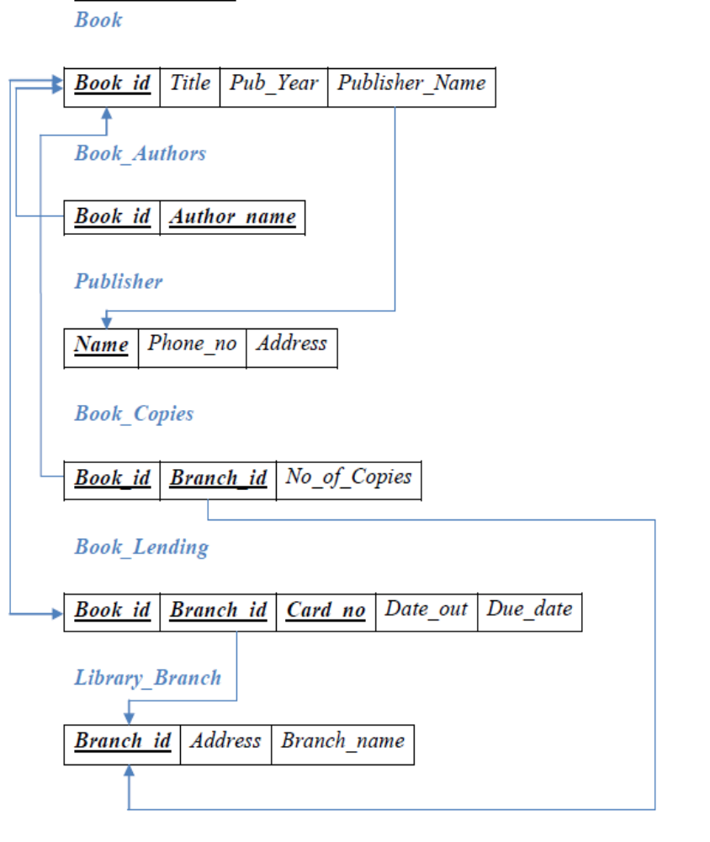

Table Creation

CREATE TABLE PUBLISHER

(NAME VARCHAR (20) PRIMARY KEY,

PHONE BIGINT,

ADDRESS VARCHAR (20));

CREATE TABLE BOOK

(BOOK_ID INTEGER PRIMARY KEY,

TITLE VARCHAR (20),

PUB_YEAR VARCHAR (20),

PUBLISHER_NAME VARCHAR (20),FOREIGN KEY(PUBLISHER_NAME) REFERENCES PUBLISHER (NAME) ON DELETE CASCADE);

CREATE TABLE BOOK_AUTHORS

(AUTHOR_NAME VARCHAR (20),

BOOK_ID INT,FOREIGN KEY(BOOK_ID) REFERENCES BOOK (BOOK_ID) ON DELETE CASCADE, PRIMARY KEY (BOOK_ID, AUTHOR_NAME));

CREATE TABLE LIBRARY_BRANCH

(BRANCH_ID INTEGER PRIMARY KEY,

BRANCH_NAME VARCHAR (50),

ADDRESS VARCHAR (50));

CREATE TABLE BOOK_COPIES

(NO_OF_COPIES INTEGER,

BOOK_ID INT,FOREIGN KEY(BOOK_ID) REFERENCES BOOK (BOOK_ID) ON DELETE CASCADE,

BRANCH_ID INT,FOREIGN KEY(BRANCH_ID) REFERENCES LIBRARY_BRANCH (BRANCH_ID) ON DELETE CASCADE,

PRIMARY KEY (BOOK_ID, BRANCH_ID));

CREATE TABLE BOOK_LENDING3

(BOOK_ID INT,
BRANCH_ID INT,
CARD_NO INT,
DATE_OUT DATE,

DUE_DATE DATE,

FOREIGN KEY(BOOK_ID) REFERENCES BOOK (BOOK_ID) ON DELETE CASCADE,

FOREIGN KEY(BRANCH_ID) REFERENCES LIBRARY_BRANCH (BRANCH_ID) ON DELETE CASCADE,

PRIMARY KEY (BOOK_ID, BRANCH_ID, CARD_NO));

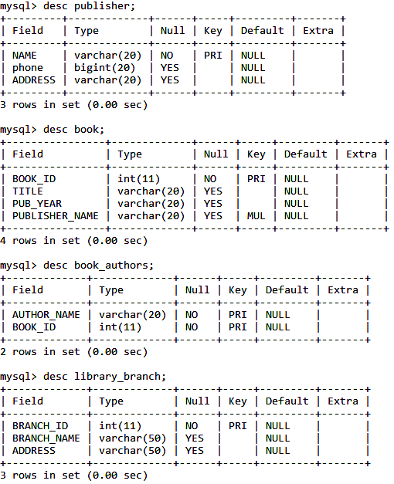
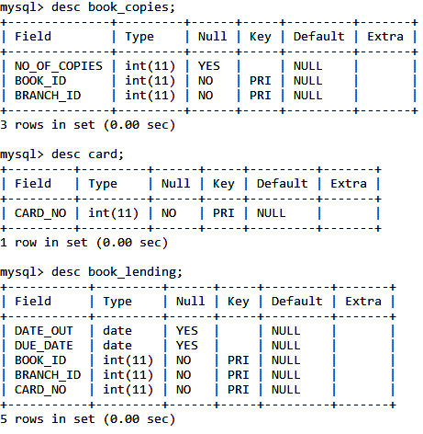

INSERT INTO PUBLISHER VALUES ('MCGRAW-HILL', 9989076587, 'BANGALORE');
INSERT INTO PUBLISHER VALUES ('PEARSON', 9889076565, 'NEWDELHI');
INSERT INTO PUBLISHER VALUES ('RANDOM HOUSE', 7455679345, 'HYDRABAD');
INSERT INTO PUBLISHER VALUES ('HACHETTE LIVRE', 8970862340, 'CHENAI');
INSERT INTO PUBLISHER VALUES ('GRUPO PLANETA', 7756120238, 'BANGALORE');

INSERT INTO BOOK VALUES (1,'DBMS','JAN-2017', 'MCGRAW-HILL');
INSERT INTO BOOK VALUES (2,'ADBMS','JUN-2016', 'MCGRAW-HILL');
INSERT INTO BOOK VALUES (3,'CN','SEP-2016', 'PEARSON');
INSERT INTO BOOK VALUES (4,'CG','SEP-2015', 'GRUPO PLANETA');
INSERT INTO BOOK VALUES (5,'OS','MAY-2016', 'PEARSON');

INSERT INTO BOOK_AUTHORS VALUES ('NAVATHE', 1);
INSERT INTO BOOK_AUTHORS VALUES ('NAVATHE', 2);
INSERT INTO BOOK_AUTHORS VALUES ('TANENBAUM', 3);
INSERT INTO BOOK_AUTHORS VALUES ('EDWARD ANGEL', 4);
INSERT INTO BOOK_AUTHORS VALUES ('GALVIN', 5);

INSERT INTO LIBRARY_BRANCH VALUES (10,'SMVITM','UDUPI');
INSERT INTO LIBRARY_BRANCH VALUES (11,'MITK','KUNDAPURA');
INSERT INTO LIBRARY_BRANCH VALUES (12,'SJEC', 'MANGALORE');
INSERT INTO LIBRARY_BRANCH VALUES (13,'AEC','BHATKAL');
INSERT INTO LIBRARY_BRANCH VALUES (14,'MIT','MANIPAL');

INSERT INTO BOOK_COPIES VALUES (10, 1, 10);
INSERT INTO BOOK_COPIES VALUES (5, 1, 11);
INSERT INTO BOOK_COPIES VALUES (2, 2, 12);
INSERT INTO BOOK_COPIES VALUES (5, 2, 13);
INSERT INTO BOOK_COPIES VALUES (7, 3, 14);
INSERT INTO BOOK_COPIES VALUES (1, 5, 10);
INSERT INTO BOOK_COPIES VALUES (3, 4, 11);

INSERT INTO BOOK_LENDING1 VALUES ('2017-01-01','2017-06-01', 1, 10, 101);
INSERT INTO BOOK_LENDING1 VALUES ('2017-01-11','2017-03-11', 3, 14, 101);
INSERT INTO BOOK_LENDING1 VALUES ('2017-02-21','2017-04-21', 2, 13, 101);
INSERT INTO BOOK_LENDING1 VALUES ('2017-03-15','2017-07-15', 4, 11, 101);
INSERT INTO BOOK_LENDING1 VALUES ('2017-04-12','2017-05-12', 1, 11, 104);

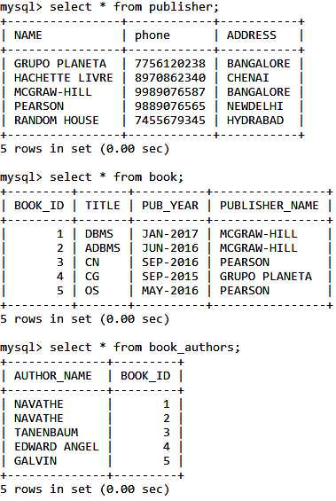

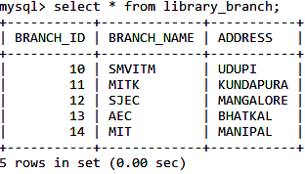
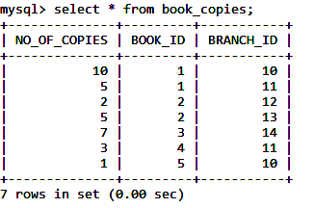

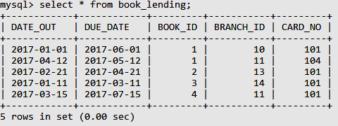

- RETRIEVE DETAILS OF ALL BOOKS IN THE LIBRARY – ID, TITLE, NAME OF PUBLISHER, AUTHORS, NUMBER OF COPIES IN EACH BRANCH, ETC.

SELECT B.BOOK_ID, B.TITLE, B.PUBLISHER_NAME, A.AUTHOR_NAME, C.NO_OF_COPIES, C.BRANCH_ID

FROM BOOK B, BOOK_AUTHORS A, BOOK_COPIES C, LIBRARY_BRANCH L WHERE B.BOOK_ID=A.BOOK_ID

AND B.BOOK_ID=C.BOOK_ID AND L.BRANCH_ID=C.BRANCH_ID;

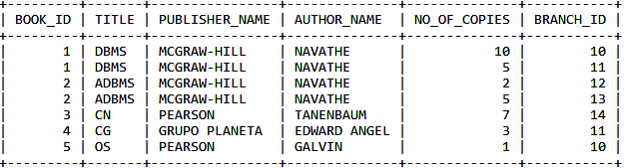

- GET THE PARTICULARS OF BORROWERS WHO HAVE BORROWED MORE THAN 3 BOOKS, BUT FROM JAN 2017 TO JUN 2017.

SELECT CARD_NO FROM BOOK_LENDING
WHERE DATE_OUT BETWEEN '2017-01-01'AND'2017-06-01'
GROUP BY CARD_NO HAVING COUNT(*)>=3;

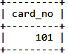

- DELETE A BOOK IN BOOK TABLE. UPDATE THE CONTENTS OF OTHER TABLES TO REFLECT THIS DATA MANIPULATION OPERATION.

DELETE FROM BOOK

WHERE BOOK_ID=3;

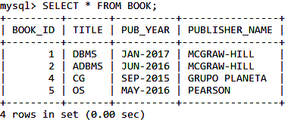

- PARTITION THE BOOK TABLE BASED ON YEAR OF PUBLICATION. DEMONSTRATE ITS WORKING WITH A SIMPLE QUERY.

CREATE VIEW V_PUBLICATION AS
SELECT * FROM BOOK GROUP BY PUB_YEAR;

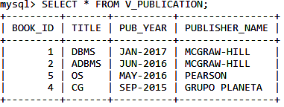

- CREATE A VIEW OF ALL BOOKS AND ITS NUMBER OF COPIES THAT ARE CURRENTLY AVAILABLE IN THE LIBRARY.

CREATE VIEW V_BOOKS AS

SELECT B.BOOK_ID, B.TITLE, C.NO_OF_COPIES,C.BRANCH_ID,L.BRANCH_NAME

FROM BOOK B, BOOK_COPIES C, LIBRARY_BRANCH L

WHERE B.BOOK_ID=C.BOOK_ID

AND C.BRANCH_ID=L.BRANCH_ID;

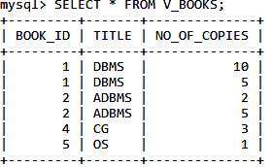

II. Consider the following schema for Order Database:

SALESMAN (Salesman_id, Name, City, Commission)
CUSTOMER (Customer_id, Cust_Name, City, Grade, Salesman_id)
ORDERS (Ord_No, Purchase_Amt, Ord_Date, Customer_id, Salesman_id)

Write SQL queries to

- Count the customers with grades above Bangalore’s average.

- Find the name and numbers of all salesmen who had more than one customer.

- List all salesmen and indicate those who have and don’t have customers in their cities (Use UNION operation.)

- Create a view that finds the salesman who has the customer with the highest order of a day.

- Demonstrate the DELETE operation by removing salesman with id 1000. All his orders must also be deleted.

Solution:

Schema Diagram

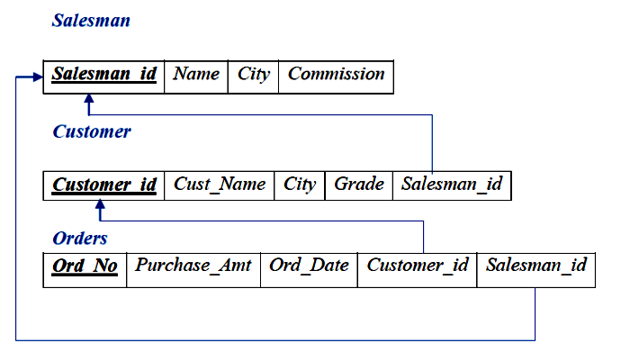

Table Creation

CREATE TABLE SALESMAN
(SALESMAN_ID INT (4),
NAME VARCHAR (20),
CITY VARCHAR (20),
COMMISSION VARCHAR (20),
PRIMARY KEY (SALESMAN_ID));

CREATE TABLE CUSTOMER1
(CUSTOMER_ID INT (4),
CUST_NAME VARCHAR (20),
CITY VARCHAR (20),
GRADE INT (3),
PRIMARY KEY (CUSTOMER_ID),
SALESMAN_ID INT (4), FOREIGN KEY (SALESMAN_ID) REFERENCES SALESMAN (SALESMAN_ID) ON DELETE SET NULL);

CREATE TABLE ORDERS
(ORD_NO INT (5),
PURCHASE_AMT INT (10),
ORD_DATE DATE,
PRIMARY KEY (ORD_NO),
CUSTOMER_ID INT (4), FOREIGN KEY (CUSTOMER_ID) REFERENCES CUSTOMER1 (CUSTOMER_ID) ON DELETE CASCADE,
SALESMAN_ID INT (4), FOREIGN KEY (SALESMAN_ID) REFERENCES SALESMAN (SALESMAN_ID) ON DELETE CASCADE);

Table Descriptions

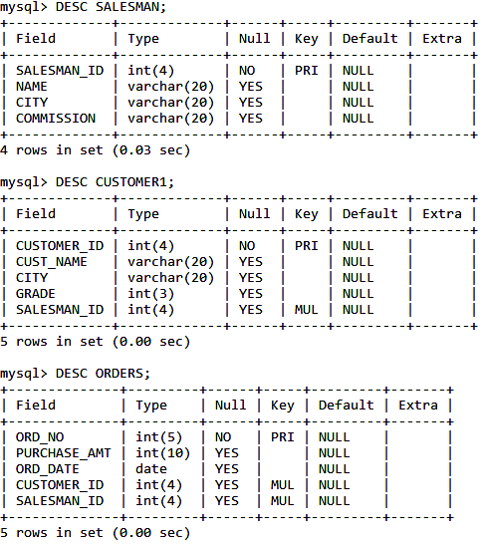

Insertion of Values to Tables

INSERT INTO SALESMAN VALUES (1000, 'JOHN','BANGALORE','25 %');
INSERT INTO SALESMAN VALUES (2000, 'RAVI','BANGALORE','20 %');
INSERT INTO SALESMAN VALUES (3000, 'KUMAR','MYSORE','15 %');
INSERT INTO SALESMAN VALUES (4000, 'SMITH','DELHI','30 %');
INSERT INTO SALESMAN VALUES (5000, 'HARSHA','HYDRABAD','15 %');

INSERT INTO CUSTOMER1 VALUES (10, 'PREETHI','BANGALORE', 100, 1000);
INSERT INTO CUSTOMER1 VALUES (11, 'VIVEK','MANGALORE', 300, 1000);
INSERT INTO CUSTOMER1 VALUES (12, 'BHASKAR','CHENNAI', 400, 2000);
INSERT INTO CUSTOMER1 VALUES (13, 'CHETHAN','BANGALORE', 200, 2000);
INSERT INTO CUSTOMER1 VALUES (14, 'MAMATHA','BANGALORE', 400, 3000);

INSERT INTO ORDERS VALUES (50, 5000, '2017-05-04', 10, 1000);
INSERT INTO ORDERS VALUES (51, 450, '2017-01-20', 10, 2000);
INSERT INTO ORDERS VALUES (52, 1000, '2017-02-24', 13, 2000);
INSERT INTO ORDERS VALUES (53, 3500, '2017-04-13', 14, 3000);
INSERT INTO ORDERS VALUES (54, 550, '2017-03-09', 12, 2000);

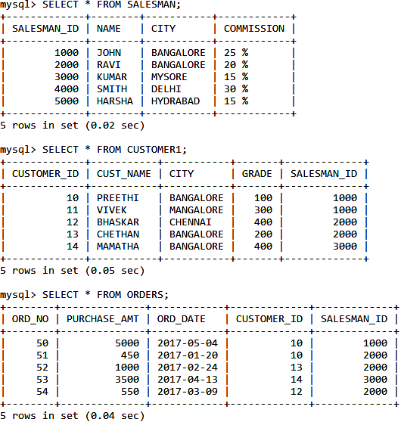

Queries:

- Count the customers with grades above Bangalore’s average.

SELECT COUNT(CUSTOMER_ID) AS CUSTOMER_COUNT
FROM CUSTOMER1
WHERE GRADE> (SELECT AVG(GRADE)
FROM CUSTOMER1
WHERE CITY='BANGALORE');

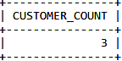

- Find the name and numbers of all salesmen who had more than one customer.

SELECT S.SALESMAN_ID, S.NAME
FROM SALESMAN S, CUSTOMER1 C
WHERE C.SALESMAN_ID=S.SALESMAN_ID
GROUP BY C.SALESMAN_ID HAVING COUNT(C.CUSTOMER_ID)>1;

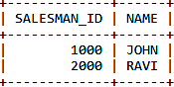

- List all salesmen and indicate those who have and don’t have customers in their cities (Use UNION operation.)

SELECT DISTINCT SALESMAN.SALESMAN_ID, NAME, CUST_NAME, COMMISSION
FROM SALESMAN, CUSTOMER1
WHERE SALESMAN.CITY = CUSTOMER1.CITY AND SALESMAN.SALESMAN_ID= CUSTOMER1.SALESMAN_ID
UNION
SELECT DISTINCT SALESMAN.SALESMAN_ID, NAME,'NO_CUSTOMER', COMMISSION
FROM SALESMAN
WHERE NOT CITY=ANY(SELECT CITY FROM CUSTOMER WHERE SALESMAN.CITY = CUSTOMER1.CITY AND SALESMAN.SALESMAN_ID= CUSTOMER.SALESMAN_ID);

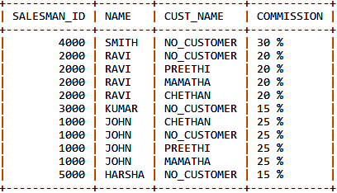

- Create a view that finds the salesman who has the customer with the highest order of a day.

CREATE VIEW HIGHEST AS SELECT ORDERS.ORD_DATE, SALESMAN.SALESMAN_ID, SALESMAN.NAME, ORDERS.PURCHASE_AMT FROM ORDERS, SALESMAN WHERE SALESMAN.SALESMAN_ID=ORDERS.SALESMAN_ID GROUP BY ORD_DATE HAVING MAX(PURCHASE_AMT);

OR

CREATE VIEW HIGHEST AS SELECT S.SALESMAN_ID, NAME, ORD_DATE,PURCHASE_AMT, CITY FROM ORDERS B, SALESMAN S WHERE S.SALESMAN_ID=B.SALESMAN_ID AND B.PURCHASE_AMT=(SELECT MAX(E.PURCHASE_AMT) FROM ORDERS E WHERE B.ORD_DATE=E.ORD_DATE);

SELECT * FROM HIGHEST;

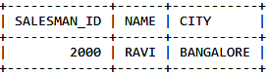

- Demonstrate the DELETE operation by removing salesman with id 1000. All his orders must also be deleted.

DELETE FROM SALESMAN
WHERE SALESMAN_ID=1000;

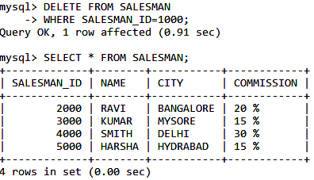

III. Consider the schema for Movie Database:

ACTOR (Act_id, Act_Name, Act_Gender)

DIRECTOR (Dir_id, Dir_Name, Dir_Phone)

MOVIES (Mov_id, Mov_Title, Mov_Year, Mov_Lang, Dir_id)

MOVIE_CAST (Act_id, Mov_id, Role)

RATING (Mov_id, Rev_Stars)

Write SQL queries to

- List the titles of all movies directed by ‘Hitchcock’.

- Find the movie names where one or more actors acted in two or more movies.

- List all actors who acted in a movie before 2000 and also in a movie after 2015 (use JOIN operation).

- Find the title of movies and number of stars for each movie that has at least one rating and find the highest number of stars that movie received. Sort the result by movie title.

- Update rating of all movies directed by ‘Steven Spielberg’ to 5.

Solution:

Schema Diagram

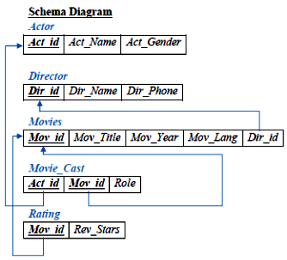

Table Creation

CREATE TABLE ACTOR(

ACT_ID INT(3),

ACT_NAME VARCHAR(20),

ACT_GENDER CHAR(1),

PRIMARY KEY(ACT_ID));

CREATE TABLE DIRECTOR (

DIR_ID INT(3),

DIR_NAME VARCHAR (20),

DIR_PHONE BIGINT(10),

PRIMARY KEY (DIR_ID));

CREATE TABLE MOVIES (

MOV_ID INT(4),

MOV_TITLE VARCHAR (25),

MOV_YEAR INT(4),

MOV_LANG VARCHAR (12),

DIR_ID INT(3),

PRIMARY KEY (MOV_ID),

FOREIGN KEY (DIR_ID) REFERENCES DIRECTOR (DIR_ID) ON DELETE CASCADE);

CREATE TABLE MOVIE_CAST (

ACT_ID INT(3),

MOV_ID INT(4),

ROLE VARCHAR (10),

PRIMARY KEY (ACT_ID, MOV_ID),

FOREIGN KEY (ACT_ID) REFERENCES ACTOR (ACT_ID),

FOREIGN KEY (MOV_ID) REFERENCES MOVIES (MOV_ID) ON DELETE CASCADE);

CREATE TABLE RATING (

MOV_ID INT(4),

REV_STARS VARCHAR (25),

PRIMARY KEY (MOV_ID),

FOREIGN KEY (MOV_ID) REFERENCES MOVIES (MOV_ID) ON DELETE CASCADE);

Table Descriptions

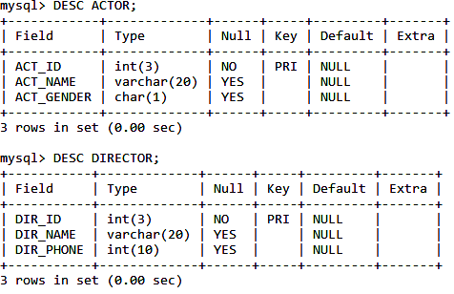
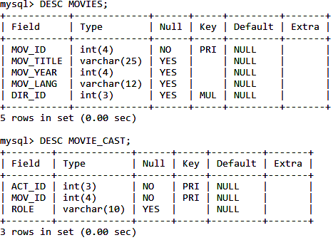

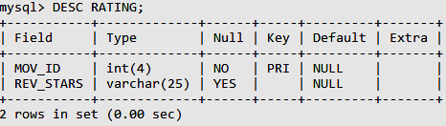
Insertion of Values to Tables

INSERT INTO ACTOR VALUES (301,'ANUSHKA','F');
INSERT INTO ACTOR VALUES (302,'PRABHAS','M');
INSERT INTO ACTOR VALUES (303,'PUNITH','M');
INSERT INTO ACTOR VALUES (304,'JERMY','M');

INSERT INTO DIRECTOR VALUES (60,'RAJAMOULI', 8751611001);
INSERT INTO DIRECTOR VALUES (61,'HITCHCOCK', 7766138911);
INSERT INTO DIRECTOR VALUES (62,'FARAN', 9986776531);
INSERT INTO DIRECTOR VALUES (63,'STEVEN', 8989776530);

INSERT INTO MOVIES VALUES (1001,'BAHUBALI-2', 2017, 'TELAGU', 60);
INSERT INTO MOVIES VALUES (1002,'BAHUBALI-1', 2015, 'TELAGU', 60);
INSERT INTO MOVIES VALUES (1003,'AKASH', 2008, 'KANNADA', 61);
INSERT INTO MOVIES VALUES (1004,'WAR HORSE', 2011, 'ENGLISH', 63);

INSERT INTO MOVIE_CAST VALUES (301, 1002, 'HEROINE');
INSERT INTO MOVIE_CAST VALUES (301, 1001, 'HEROINE');
INSERT INTO MOVIE_CAST VALUES (303, 1003, 'HERO');
INSERT INTO MOVIE_CAST VALUES (303, 1002, 'GUEST');
INSERT INTO MOVIE_CAST VALUES (304, 1004, 'HERO');

INSERT INTO RATING VALUES (1001, 4);
INSERT INTO RATING VALUES (1002, 2);
INSERT INTO RATING VALUES (1003, 5);
INSERT INTO RATING VALUES (1004, 4);

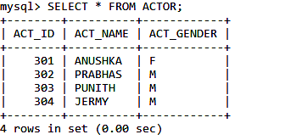
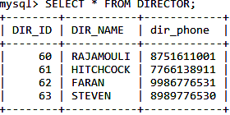
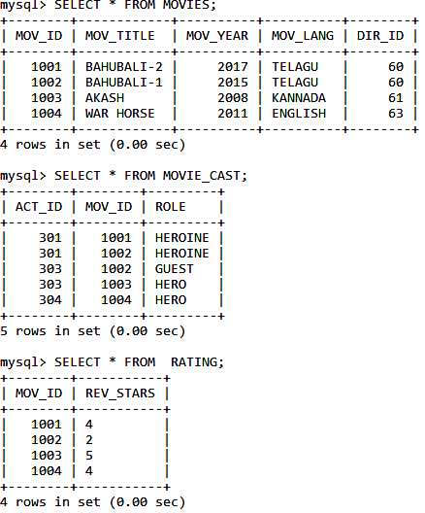

Queries:

- List the titles of all movies directed by ‘Hitchcock’.

SELECT M.MOV_TITLE
FROM MOVIES M, DIRECTOR D
WHERE M.DIR_ID= D.DIR_ID AND DIR_NAME = 'HITCHCOCK';

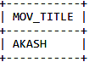

- Find the movie names where one or more actors acted in two or more movies.

SELECT MOV_TITLE
FROM MOVIES M, MOVIE_CAST MV
WHERE M.MOV_ID=MV.MOV_ID AND ACT_ID IN (SELECT ACT_ID FROM MOVIE_CAST GROUP BY ACT_ID HAVING COUNT(ACT_ID)>1)
GROUP BY MOV_TITLE
HAVING COUNT(*)>1;

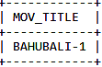

- List all actors who acted in a movie before 2000 and also in a movie after 2015 (use JOIN operation).
SELECT A.ACT_NAME, M.MOV_TITLE, M.MOV_YEAR
FROM ACTOR A
JOIN MOVIE_CAST C
ON A.ACT_ID=C.ACT_ID
JOIN MOVIES M
ON C.MOV_ID=M.MOV_ID
WHERE M.MOV_YEAR NOT BETWEEN 2000 AND 2015;

OR

SELECT A.ACT_NAME, A.ACT_NAME, C.MOV_TITLE, C.MOV_YEAR
FROM ACTOR A, MOVIE_CAST B, MOVIES C
WHERE A.ACT_ID=B.ACT_ID AND B.MOV_ID=C.MOV_ID
AND C.MOV_YEAR NOT BETWEEN 2000 AND 2015;

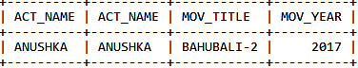

- Find the title of movies and number of stars for each movie that has at least one rating and find the highest number of stars that movie received. Sort the result by movie title.

SELECT MOV_TITLE, MAX(REV_STARS)
FROM MOVIES M, RATING R
WHERE M.MOV_ID=R.MOV_ID
GROUP BY R.MOV_ID
ORDER BY MOV_TITLE;

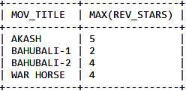

- Update rating of all movies directed by ‘Steven Spielberg’ to 5

UPDATE RATING SET REV_STARS=5
WHERE MOV_ID IN (SELECT MOV_ID FROM MOVIES
WHERE DIR_ID IN (SELECT DIR_ID
FROM DIRECTOR
WHERE DIR_NAME='STEVEN'));

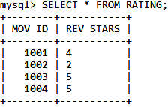

Consider the schema for College Database:

STUDENT (USN, SName, Address, Phone, Gender) SEMSEC (SSID, Sem, Sec)
CLASS (USN, SSID)
SUBJECT (Subcode, Title, Sem, Credits)
IAMARKS (USN, Subcode, SSID, Test1, Test2, Test3, FinalIA) Write SQL queries to

List all the student details studying in fourth semester ‘C’ section.
  - Compute the total INT of male and female students in each semester and in each section.
  - Create a view of Test1 marks of student USN ‘1BI15CS101’ in all subjects.
  - Calculate the FinalIA (average of best two test marks) and update the corresponding table for all students.
  - Categorize students based on the following criterion: If FinalIA = 17 to 20 then CAT = ‘Outstanding’
If FinalIA = 12 to 16 then CAT = ‘Average’ If FinalIA< 12 then CAT = ‘Weak’
Give these details only for 8th semester A, B, and C section students.
Solution:

Schema Diagram
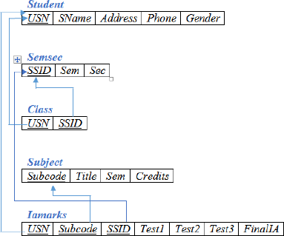
Table Creation
CREATE TABLE STUDENT (
USN VARCHAR (10) PRIMARY KEY, SNAME VARCHAR (25),
ADDRESS VARCHAR (25),
PHONE INT (10),
GENDER CHAR (1));

CREATE TABLE SEMSEC (
SSID VARCHAR (5) PRIMARY KEY, SEM INT (2),
SEC CHAR (1));

CREATE TABLE CLASS ( USN VARCHAR (10),
SSID VARCHAR (5), PRIMARY KEY (USN, SSID),
FOREIGN KEY (USN) REFERENCES STUDENT (USN), FOREIGN KEY (SSID) REFERENCES SEMSEC (SSID));

CREATE TABLE SUBJECT ( SUBCODE VARCHAR (8),
TITLE VARCHAR (20),
SEM INT (2),
CREDITS INT (2),
PRIMARY KEY (SUBCODE));

CREATE TABLE IAMARKS ( USN VARCHAR (10),
SUBCODE VARCHAR (8),
SSID VARCHAR (5),
TEST1 INT (2),
TEST2 INT (2),
TEST3 INT (2),
FINALIA INT (2),
PRIMARY KEY (USN, SUBCODE, SSID),
FOREIGN KEY (USN) REFERENCES STUDENT (USN), FOREIGN KEY (SUBCODE) REFERENCES SUBJECT (SUBCODE), FOREIGN KEY (SSID) REFERENCES SEMSEC (SSID));
Table Descriptions

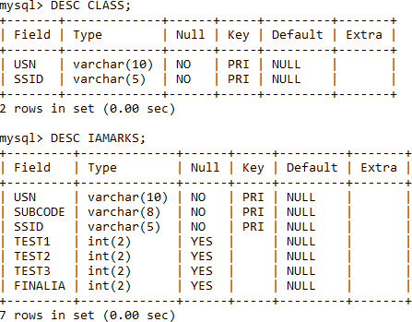
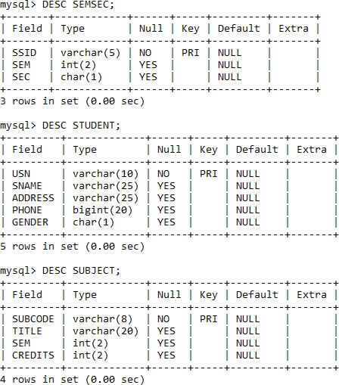
Insertion of values to tables

INSERT INTO STUDENT VALUES ('4MW13CS020','AKSHAY','BELAGAVI', 8877881122,'M'); INSERT INTO STUDENT VALUES ('4MW13CS062','SANDHYA','BENGALURU', 7722829912,'F');
INSERT INTO STUDENT VALUES ('4MW13CS091','TEESHA','BENGALURU', 7712312312,'F');
INSERT INTO STUDENT VALUES ('4MW13CS066','SUPRIYA','MANGALURU', 8877881122,'F');
INSERT INTO STUDENT VALUES ('4MW14CS010','ABHAY','BENGALURU', 9900211201,'M');
INSERT INTO STUDENT VALUES ('4MW14CS032','BHASKAR','BENGALURU', 9923211099,'M');
INSERT INTO STUDENT VALUES ('4MW14CS025','ASMI','BENGALURU', 7894737377,'F'); INSERT INTO STUDENT VALUES ('4MW15CS011','AJAY','TUMKUR', 9845091341,'M'); INSERT INTO STUDENT VALUES ('4MW15CS029','CHITRA','DAVANGERE', 7696772121,'F');
INSERT INTO STUDENT VALUES ('4MW15CS045','JEEVA','BELLARY', 9944850121,'M'); INSERT INTO STUDENT VALUES ('4MW15CS091','SANTOSH','MANGALURU', 8812332201,'M');
INSERT INTO STUDENT VALUES ('4MW16CS045','ISMAIL','KALBURGI', 9900232201,'M'); INSERT INTO STUDENT VALUES ('4MW16CS088','SAMEERA','SHIMOGA', 9905542212,'F'); INSERT INTO STUDENT VALUES ('4MW16CS122','VINAYAKA','CHIKAMAGALUR', 8800880011,'M');

INSERT INTO SEMSEC VALUES ('CSE8A', 8,'A'); INSERT INTO SEMSEC VALUES ('CSE8B', 8,'B'); INSERT INTO SEMSEC VALUES ('CSE8C', 8,'C'); INSERT INTO SEMSEC VALUES ('CSE7A', 7,'A'); INSERT INTO SEMSEC VALUES ('CSE7B', 7,'B'); INSERT INTO SEMSEC VALUES ('CSE7C', 7,'C'); INSERT INTO SEMSEC VALUES ('CSE6A', 6,'A'); INSERT INTO SEMSEC VALUES ('CSE6B', 6,'B'); INSERT INTO SEMSEC VALUES ('CSE6C', 6,'C'); INSERT INTO SEMSEC VALUES ('CSE5A', 5,'A'); INSERT INTO SEMSEC VALUES ('CSE5B', 5,'B'); INSERT INTO SEMSEC VALUES ('CSE5C', 5,'C'); INSERT INTO SEMSEC VALUES ('CSE4A', 4,'A'); INSERT INTO SEMSEC VALUES ('CSE4B', 4,'B'); INSERT INTO SEMSEC VALUES ('CSE4C', 4,'C'); INSERT INTO SEMSEC VALUES ('CSE3A', 3,'A'); INSERT INTO SEMSEC VALUES ('CSE3B', 3,'B'); INSERT INTO SEMSEC VALUES ('CSE3C', 3,'C'); INSERT INTO SEMSEC VALUES ('CSE2A', 2,'A'); INSERT INTO SEMSEC VALUES ('CSE2B', 2,'B'); INSERT INTO SEMSEC VALUES ('CSE2C', 2,'C'); INSERT INTO SEMSEC VALUES ('CSE1A', 1,'A'); INSERT INTO SEMSEC VALUES ('CSE1B', 1,'B'); INSERT INTO SEMSEC VALUES ('CSE1C', 1,'C');

INSERT INTO CLASS VALUES ('4MW13CS020','CSE8A'); INSERT INTO CLASS VALUES ('4MW13CS062','CSE8A'); INSERT INTO CLASS VALUES ('4MW13CS066','CSE8B'); INSERT INTO CLASS VALUES ('4MW13CS091','CSE8C'); INSERT INTO CLASS VALUES ('4MW14CS010','CSE7A'); INSERT INTO CLASS VALUES ('4MW14CS025','CSE7A'); INSERT INTO CLASS VALUES ('4MW14CS032','CSE7A'); INSERT INTO CLASS VALUES ('4MW15CS011','CSE4A'); INSERT INTO CLASS VALUES ('4MW15CS029','CSE4A'); INSERT INTO CLASS VALUES ('4MW15CS045','CSE4B'); INSERT INTO CLASS VALUES ('4MW15CS091','CSE4C'); INSERT INTO CLASS VALUES ('4MW16CS045','CSE3A'); INSERT INTO CLASS VALUES ('4MW16CS088','CSE3B'); INSERT INTO CLASS VALUES ('4MW16CS122','CSE3C');

INSERT INTO SUBJECT VALUES ('10CS81','ACA', 8, 4); INSERT INTO SUBJECT VALUES ('10CS82','SSM', 8, 4); INSERT INTO SUBJECT VALUES ('10CS83','NM', 8, 4); INSERT INTO SUBJECT VALUES ('10CS84','CC', 8, 4); INSERT INTO SUBJECT VALUES ('10CS85','PW', 8, 4); INSERT INTO SUBJECT VALUES ('10CS71','OOAD', 7, 4); INSERT INTO SUBJECT VALUES ('10CS72','ECS', 7, 4); INSERT INTO SUBJECT VALUES ('10CS73','PTW', 7, 4); INSERT INTO SUBJECT VALUES ('10CS74','DWDM', 7, 4); INSERT INTO SUBJECT VALUES ('10CS75','JAVA', 7, 4); INSERT INTO SUBJECT VALUES ('10CS76','SAN', 7, 4); INSERT INTO SUBJECT VALUES ('15CS51', 'ME', 5, 4); INSERT INTO SUBJECT VALUES ('15CS52','CN', 5, 4); INSERT INTO SUBJECT VALUES ('15CS53','DBMS', 5, 4); INSERT INTO SUBJECT VALUES ('15CS54','ATC', 5, 4); INSERT INTO SUBJECT VALUES ('15CS55','JAVA', 5, 3); INSERT INTO SUBJECT VALUES ('15CS56','AI', 5, 3); INSERT INTO SUBJECT VALUES ('15CS41','M4', 4, 4); INSERT INTO SUBJECT VALUES ('15CS42','SE', 4, 4); INSERT INTO SUBJECT VALUES ('15CS43','DAA', 4, 4); INSERT INTO SUBJECT VALUES ('15CS44','MPMC', 4, 4); INSERT INTO SUBJECT VALUES ('15CS45','OOC', 4, 3); INSERT INTO SUBJECT VALUES ('15CS46','DC', 4, 3); INSERT INTO SUBJECT VALUES ('15CS31','M3', 3, 4); INSERT INTO SUBJECT VALUES ('15CS32','ADE', 3, 4); INSERT INTO SUBJECT VALUES ('15CS33','DSA', 3, 4); INSERT INTO SUBJECT VALUES ('15CS34','CO', 3, 4); INSERT INTO SUBJECT VALUES ('15CS35','USP', 3, 3); INSERT INTO SUBJECT VALUES ('15CS36','DMS', 3, 3);

INSERT INTO IAMARKS (USN, SUBCODE, SSID, TEST1, TEST2, TEST3) VALUES ('4MW13CS091','10CS81','CSE8C', 15, 16, 18);
INSERT INTO IAMARKS (USN, SUBCODE, SSID, TEST1, TEST2, TEST3) VALUES ('4MW13CS091','10CS82','CSE8C', 12, 19, 14);
INSERT INTO IAMARKS (USN, SUBCODE, SSID, TEST1, TEST2, TEST3) VALUES ('4MW13CS091','10CS83','CSE8C', 19, 15, 20);
INSERT INTO IAMARKS (USN, SUBCODE, SSID, TEST1, TEST2, TEST3) VALUES ('4MW13CS091','10CS84','CSE8C', 20, 16, 19);
INSERT INTO IAMARKS (USN, SUBCODE, SSID, TEST1, TEST2, TEST3) VALUES ('4MW13CS091','10CS85','CSE8C', 15, 15, 12);
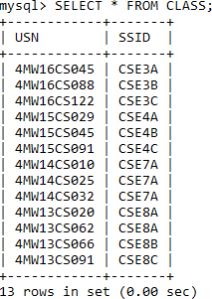
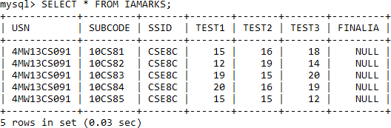
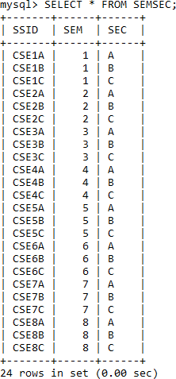

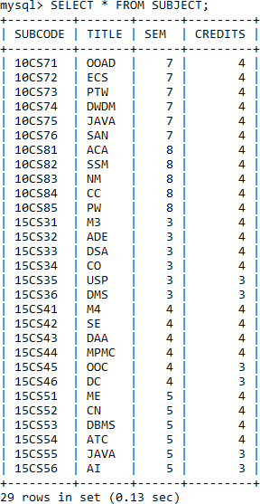
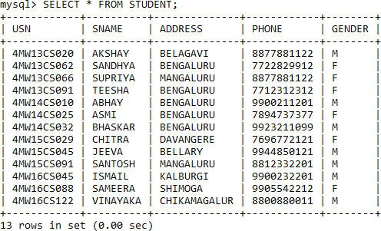
Queries:

- List all the student details studying in fourth semester ‘C’ section.

SELECT S.*, SS.SEM, SS.SEC
FROM STUDENT S, SEMSEC SS, CLASS C WHERE S.USN = C.USN AND SS.SSID = C.SSID AND SS.SEM = 4 AND SS.SEc='C';
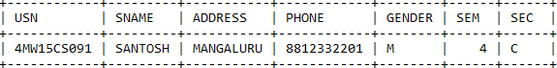

Compute the total number of male and female students in each semester and in each section.
SELECT SS.SEM, SS.SEC, S.GENDER, COUNT(S.GENDER) AS COUNT FROM STUDENT S, SEMSEC SS, CLASS C
WHERE S.USN = C.USN AND SS.SSID = C.SSID
GROUP BY SS.SEM, SS.SEC, S.GENDER ORDER BY SEM;
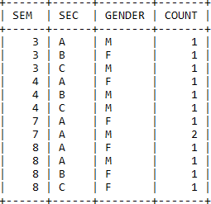

Create a view of Test1 marks of student USN ‘1BI15CS101’ in all subjects.
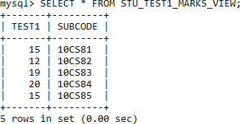
CREATE VIEW STU_TEST1_MARKS_VIEW AS SELECT TEST1, SUBCODE FROM IAMARKS WHERE USN ='4MW13CS091';

Calculate the FinalIA (average of best two test marks) and update the corresponding table for all students.

CREATE OR REPLACE PROCEDURE AVGMARKS IS
CURSOR C_IAMARKS IS
SELECT GREATEST(TEST1,TEST2) AS A, GREATEST(TEST1,TEST3) AS B, GREATEST(TEST3,TEST2) AS C
FROM IAMARKS
WHERE FINALIA IS NULL FOR UPDATE;
C_A NUMBER;
C_B NUMBER;
C_C NUMBER;
C_SM NUMBER;
C_AV NUMBER;
BEGIN
OPEN C_IAMARKS; LOOP
FETCH C_IAMARKS INTO C_A, C_B, C_C; EXIT WHEN C_IAMARKS%NOTFOUND;
--DBMS_OUTPUT.PUT_LINE(C_A || ' ' || C_B || ' ' || C_C); IF (C_A != C_B) THEN
C_SM:=C_A+C_B; ELSE C_SM:=C_A+C_C; END IF; C_AV:=C_SM/2;
--DBMS_OUTPUT.PUT_LINE('SUM = '||C_SM);
--DBMS_OUTPUT.PUT_LINE('AVERAGE = '||C_AV);
UPDATE IAMARKS SET FINALIA=C_AV WHERE CURRENT OF C_IAMARKS; END LOOP;
CLOSE C_IAMARKS;
END;
OR
UPDATE IAMARKS SET FINALIA=NULL;
UPDATE IAMARKS SET FINALIA=((TEST1+TEST2+TEST3)-LEAST(TEST1,TEST2,TEST3))/2;
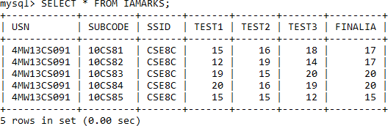

Categorize students based on the following criterion:

If FinalIA = 17 to 20 then CAT = ‘Outstanding’ If FinalIA = 12 to 16 then CAT = ‘Average’
If FinalIA< 12 then CAT = ‘Weak’
th

Give these details only for 8 semester A, B, and C section students.

SELECT S.USN,S.SNAME,S.ADDRESS,S.PHONE,S.GENDER,SS.SEM,SS.SEC, (CASE
WHEN IA.FINALIA BETWEEN 17 AND 20 THEN 'OUTSTANDING' WHEN IA.FINALIA BETWEEN 12 AND 16 THEN 'AVERAGE' ELSE'WEAK'
END) AS CAT
FROM STUDENT S, SEMSEC SS, IAMARKS IA WHERE S.USN = IA.USN AND
SS.SSID = IA.SSID AND SS.SEM = 8
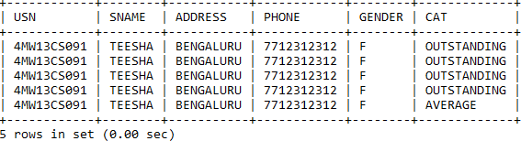
AND SS.SEC IN('A','B','C');

Consider the schema for Company Database:

EMPLOYEE (SSN, Name, Address, Sex, Salary, SuperSSN, DNo) DEPARTMENT (DNo, DName, MgrSSN, MgrStartDate)
DLOCATION (DNo,DLoc)
PROJECT (PNo, PName, PLocation, DNo) WORKS_ON (SSN, PNo, Hours)

Write SQL queries to
  - Make a list of all project numbers for projects that involve an employee whose last name is ‘Scott’, either as a worker or as a manager of the department that controls the project.
  - Show the resulting salaries if every employee working on the ‘IoT’ project is given a 10 percent raise.
  - Find the sum of the salaries of all employees of the ‘Accounts’ department, as well as the maximum salary, the minimum salary, and the average salary in this department
  - Retrieve the name of each employee who works on all the projects controlled by department number 5 (use NOT EXISTS operator). For each department that has more than five employees, retrieve the department number and the number of its employees who are making more than Rs. 6,00,000.

Schema Diagram
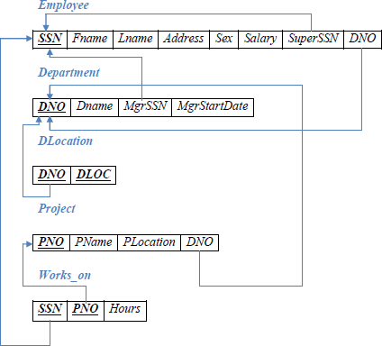
Table Creation

CREATE TABLE DEPARTMENT (DNO VARCHAR (20) PRIMARY KEY, DNAME VARCHAR (20), MGRSTARTDATE DATE);

CREATE TABLE EMPLOYEE
(SSN VARCHAR (20) PRIMARY KEY, FNAME VARCHAR (20),
LNAME VARCHAR (20),
ADDRESS VARCHAR (20),
SEX CHAR (1), SALARY INTEGER,
SUPERSSN VARCHAR(2),
FOREIGN KEY(SUPERSSN) REFERENCES EMPLOYEE (SSN), DNO VARCHAR(2),
FOREIGN KEY (DNO) REFERENCES DEPARTMENT (DNO));

NOTE: Once DEPARTMENT and EMPLOYEE tables are created we must alter department table to add foreign constraint MGRSSN using sql command

ALTER TABLE DEPARTMENT ADD MGRSSN VARCHAR(20);

ALTER TABLE DEPARTMENT
ADD FOREIGN KEY(MGRSSN) REFERENCES EMPLOYEE (SSN);

CREATE TABLE DLOCATION (DLOC VARCHAR (20),
DNO VARCHAR(2),
FOREIGN KEY(DNO) REFERENCES DEPARTMENT (DNO), PRIMARY KEY (DNO, DLOC));

CREATE TABLE PROJECT (PNO INTEGER PRIMARY KEY, PNAME VARCHAR (20),
PLOCATION VARCHAR (20), DNO VARCHAR(2),
FOREIGN KEY(DNO) REFERENCES DEPARTMENT (DNO));
CREATE TABLE WORKS_ON (HOURS INT (2),
SSN VARCHAR(20),
FOREIGN KEY(SSN) REFERENCES EMPLOYEE (SSN), PNO INTEGER,
FOREIGN KEY (PNO) REFERENCES PROJECT(PNO),
PRIMARY KEY (SSN, PNO));

Table Descriptions
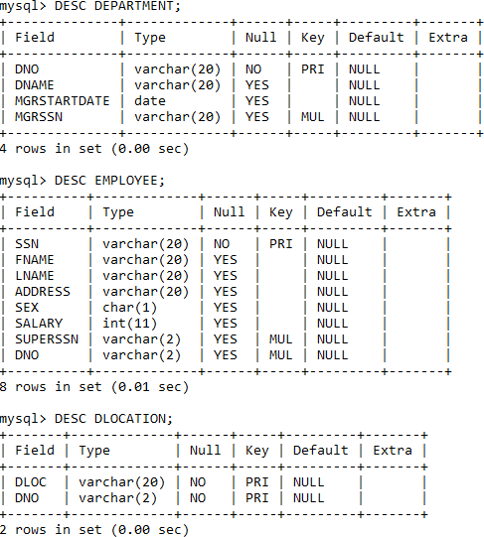

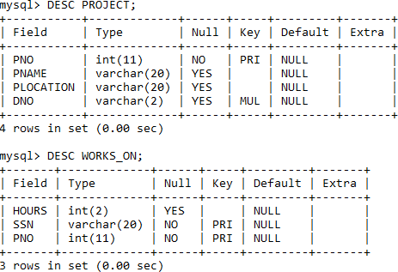

Insert The values

INSERT INTO EMPLOYEE (SSN, FNAME, LNAME, ADDRESS, SEX, SALARY) VALUES ('SMVECE01','JOHN','SCOTT','BANGALORE','M', 450000);
INSERT INTO EMPLOYEE (SSN, FNAME, LNAME, ADDRESS, SEX, SALARY) VALUES ('SMVCSE01','JAMES','SMITH','BANGALORE','M', 500000);
INSERT INTO EMPLOYEE (SSN, FNAME, LNAME, ADDRESS, SEX, SALARY) VALUES ('SMVCSE02','HEARN','BAKER','BANGALORE','M', 700000);
INSERT INTO EMPLOYEE (SSN, FNAME, LNAME, ADDRESS, SEX, SALARY) VALUES ('SMVCSE03','EDWARD','SCOTT','MYSORE','M', 500000);
INSERT INTO EMPLOYEE (SSN, FNAME, LNAME, ADDRESS, SEX, SALARY) VALUES ('SMVCSE04','PAVAN','HEGDE','MANGALORE','M', 650000);
INSERT INTO EMPLOYEE (SSN, FNAME, LNAME, ADDRESS, SEX, SALARY) VALUES ('SMVCSE05','GIRISH','MALYA','MYSORE','M', 450000);
INSERT INTO EMPLOYEE (SSN, FNAME, LNAME, ADDRESS, SEX, SALARY) VALUES ('SMVCSE06','NEHA','SN','BANGALORE','F', 800000);
INSERT INTO EMPLOYEE (SSN, FNAME, LNAME, ADDRESS, SEX, SALARY) VALUES ('SMVACC01','AHANA','K','MANGALORE','F', 350000);
INSERT INTO EMPLOYEE (SSN, FNAME, LNAME, ADDRESS, SEX, SALARY) VALUES ('SMVACC02','SANTHOSH','KUMAR','MANGALORE','M', 300000); INSERT INTO EMPLOYEE (SSN, FNAME, LNAME, ADDRESS, SEX, SALARY) VALUES ('SMVISE01','VEENA','M','MYSORE','M', 600000);
INSERT INTO EMPLOYEE (SSN, FNAME, LNAME, ADDRESS, SEX, SALARY) VALUES ('SMVIT01','NAGESH','HR','BANGALORE','M', 500000);

INSERT INTO DEPARTMENT VALUES ('1','ACCOUNTS','2001-01-01','SMVACC02'); INSERT INTO DEPARTMENT VALUES ('2','IT','2016-08-01','SMVIT01');
INSERT INTO DEPARTMENT VALUES ('3','ECE','2008-06-01','SMVECE01'); INSERT INTO DEPARTMENT VALUES ('4','ISE','2015-08-01','SMVISE01'); INSERT INTO DEPARTMENT VALUES ('5','CSE','2002-06-02','SMVCSE05');
Note: update entries of employee table to fill missing fields SUPERSSN and DNO UPDATE EMPLOYEE SET
SUPERSSN=NULL, DNO='3'
WHERE SSN='SMVECE01';

UPDATE EMPLOYEE SET SUPERSSN='SMVCSE02', DNO='5' WHERE SSN='SMVCSE01';

UPDATE EMPLOYEE SET SUPERSSN='SMVCSE03', DNO='5' WHERE SSN='SMVCSE02';

UPDATE EMPLOYEE SET SUPERSSN='SMVCSE04', DNO='5'
WHERE SSN='SMVCSE03';

UPDATE EMPLOYEE SET DNO='5', SUPERSSN='SMVCSE05' WHERE SSN='SMVCSE04';

UPDATE EMPLOYEE SET DNO='5', SUPERSSN='SMVCSE06' WHERE SSN='SMVCSE05';

UPDATE EMPLOYEE SET DNO='5', SUPERSSN=NULL WHERE SSN='SMVCSE06';

UPDATE EMPLOYEE SET DNO='1', SUPERSSN='SMVACC02' WHERE SSN='SMVACC01';

UPDATE EMPLOYEE SET DNO='1', SUPERSSN=NULL WHERE SSN='SMVACC02';

UPDATE EMPLOYEE SET DNO='4', SUPERSSN=NULL WHERE SSN='SMVISE01';

UPDATE EMPLOYEE SET DNO='2', SUPERSSN=NULL WHERE SSN='SMVIT01';

INSERT INTO DLOCATION VALUES ('BANGALORE', '1');
INSERT INTO DLOCATION VALUES ('BANGALORE', '2');
INSERT INTO DLOCATION VALUES ('BANGALORE', '3');
INSERT INTO DLOCATION VALUES ('MANGALORE', '4');
INSERT INTO DLOCATION VALUES ('MANGALORE', '5');

INSERT INTO PROJECT VALUES (100,'IOT','BANGALORE','5');
INSERT INTO PROJECT VALUES (101,'CLOUD','BANGALORE','5');
INSERT INTO PROJECT VALUES (102,'BIGDATA','BANGALORE','5');
INSERT INTO PROJECT VALUES (103,'SENSORS','BANGALORE','3');
INSERT INTO PROJECT VALUES (104,'BANK MANAGEMENT','BANGALORE','1'); INSERT INTO PROJECT VALUES (105,'SALARY MANAGEMENT','BANGALORE','1');
INSERT INTO PROJECT VALUES (106,'OPENSTACK','BANGALORE','4');
INSERT INTO PROJECT VALUES (107,'SMART CITY','BANGALORE','2');

INSERT INTO WORKS_ON VALUES (4, 'SMVCSE01', 100);
INSERT INTO WORKS_ON VALUES (6, 'SMVCSE01', 101);
INSERT INTO WORKS_ON VALUES (8, 'SMVCSE01', 102);
INSERT INTO WORKS_ON VALUES (10, 'SMVCSE02', 100);
INSERT INTO WORKS_ON VALUES (3, 'SMVCSE04', 100);
INSERT INTO WORKS_ON VALUES (4, 'SMVCSE05', 101); INSERT INTO WORKS_ON VALUES (5, 'SMVCSE06', 102);
INSERT INTO WORKS_ON VALUES (6, 'SMVCSE03', 102);
INSERT INTO WORKS_ON VALUES (7, 'SMVECE01', 103);
INSERT INTO WORKS_ON VALUES (5, 'SMVACC01', 104);
INSERT INTO WORKS_ON VALUES (6, 'SMVACC02', 105);
INSERT INTO WORKS_ON VALUES (4, 'SMVISE01', 106);
INSERT INTO WORKS_ON VALUES (10, 'SMVIT01', 107);

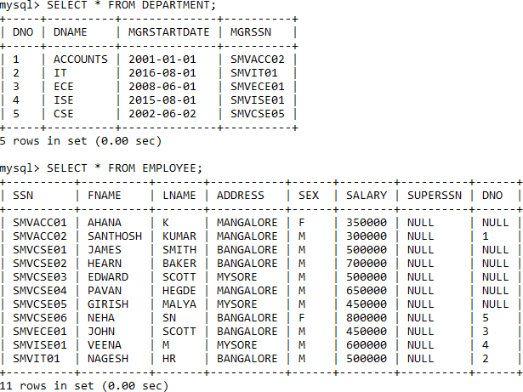
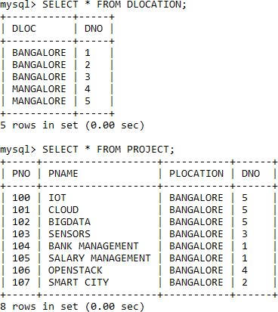

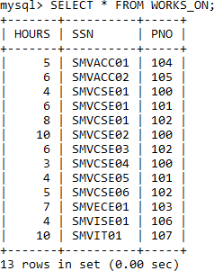

Queries:

- Make a list of all project numbers for projects that involve an employee whose last name is ‘Scott’, either as a worker or as a manager of the department that controls the project.

(SELECT DISTINCT P.PNO
FROM PROJECT P, DEPARTMENT D, EMPLOYEE E WHERE E.DNO=D.DNO
AND D.MGRSSN=E.SSN AND E.LNAME=’SCOTT’) UNION
(SELECT DISTINCT P1.PNO
FROM PROJECT P1, WORKS_ON W, EMPLOYEE E1 WHERE P1.PNO=W.PNO
AND E1.SSN=W.SSN
AND E1.LNAME=’SCOTT’);

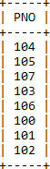

- Show the resulting salaries if every employee working on the ‘IoT’ project is given a 10 percent raise.

SELECT E.FNAME, E.LNAME, 1.1*E.SALARY AS INCR_SAL FROM EMPLOYEE E, WORKS_ON W, PROJECT P
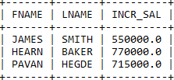
WHERE E.SSN=W.SSN AND W.PNO=P.PNO AND P.PNAME=’IOT’;

- Find the sum of the salaries of all employees of the ‘Accounts’ department, as well as the maximum salary, the minimum salary, and the average salary in this department

SELECT SUM (E.SALARY), MAX (E.SALARY), MIN (E.SALARY), AVG (E.SALARY) FROM EMPLOYEE E, DEPARTMENT D
WHERE E.DNO=D.DNO
AND D.DNAME=’ACCOUNTS’;
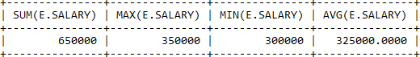

- Retrieve the name of each employee who works on all the projects Controlled by department number 5 (use NOT EXISTS operator).

SELECT E.FNAME, E.LNAME FROM EMPLOYEE E
WHERE NOT EXISTS(SELECT P.PNO FROM PROJECT P
WHERE DNO='5' AND P.PNO NOT IN (SELECT W.PNO FROM WORKS_ON W WHERE E.SSN=W.SSN));
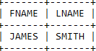
- For each department that has more than five employees, retrieve the department number and the number of its employees who are making more than Rs. 6, 00,000.

SELECT D.DNO, COUNT(*)
FROM DEPARTMENT D, EMPLOYEE E WHERE D.DNO=E.DNO
AND E.SALARY>600000
AND D.DNO IN (SELECT E1.DNO FROM EMPLOYEE E1
GROUP BY E1.DNO HAVING COUNT(*)>5) ;
